T.POOJITHA (192412318) ITA0609
Exp-10 : Write a Python Program to Implement Expectation & Maximization Algorithm
Aim
To write a Python program to implement the Expectation-Maximization (EM) algorithm for clustering data into different groups.
Algorithm
- Import the required Python libraries.
- Create or load the input dataset.
- Initialize the number of clusters.
- Apply the Expectation step to calculate the probability of each data point belonging to each cluster.
- Apply the Maximization step to update the cluster parameters.
- Repeat the E-step and M-step until the model converges.
- Display the final cluster assignments.
Program code
# Import required libraries
from sklearn.datasets import load_iris
from sklearn.mixture import GaussianMixture # Load the Iris dataset
iris = load_iris()
X = iris.data
# Create the Gaussian Mixture Model (EM Algorithm)
gmm = GaussianMixture(n_components=3, random_state=42) # Train the model
gmm.fit(X)
# Predict cluster labels labels = gmm.predict(X) # Display results
print("Cluster Labels:") print(labels)
print("\nMeans of Clusters:") print(gmm.means_)
Sample Input
Data = [1.0, 1.2, 1.4, 5.0, 5.2, 5.4]
Number of clusters = 2

Output:
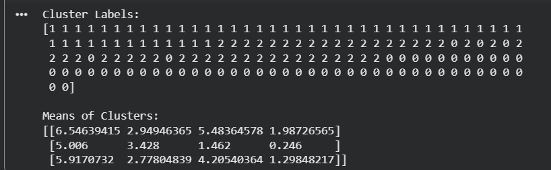

Conclusion: The EM algorithm successfully grouped the given data into two clusters based on their probability distribution.

